10th International Congress of Serbian Society of Mechanics
Niš, Serbia, June 18-20, 2025
Jian Deng, Ph.D.
Hosted by the Serbian Society of Mechanics at the Faculty of Mechanical Engineering and the Faculty of Civil Engineering and Architecture, University of Niš
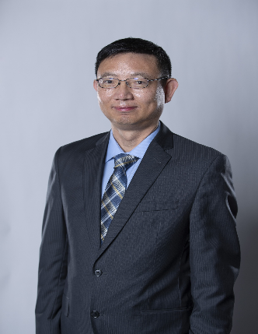
Short Professioal details and affiliation:
Dr. Jian Deng is a Professor at Lakehead University with 30 years of experience in Engineering Sciences. Specializing in dynamic stability and structural reliability, he advances theories and techniques for analyzing and designing underground excavations, structural elements, and engineering systems. He holds a Ph.D. from the University of Waterloo, Canada, and is passionate about research, teaching, and programming.

Plenary lecture
Dynamic Stability of Structures under Multi-Hazards
Abstract: Natural hazards pose significant risks to people and infrastructure worldwide. Traditional stability assessment approaches often focus on individual hazards, overlooking the cumulative and cascading effects of multi-hazard scenarios. This can lead to inaccurate stability estimations, as the combined impact of multiple hazards—such as earthquakes, vibrations, landslides, and water waves—may differ significantly from the sum of their individual effects.
This talk explores the dynamic stability of structures under multi-hazard conditions, using pile foundations in Lake Superior as a case study. The equations of motion for pile foundations subjected to multiple excitations are derived using Hamilton’s principle. Analytical and numerical methods are employed to identify dynamic instability regions, with a particular focus on parametric resonances. The numerically accurate diagrams are used to calibrate the approximate analytical instability boundaries of various orders of the method harminc balance. The numerical method can also overcome the limitations of small-parameter assumptions inherent in perturbative and averaging techniques. The findings provide new insights into structural behavior under complex hazard interactions, contributing to more robust and resilient infrastructure design.

