**10th International Congress of Serbian Society of Mechanics**

**Niš, Serbia, June 18-20, 2025**

**Xingcheng Gan, Ph.D.**

**Hosted by the Serbian Society of Mechanics at the Faculty of Mechanical Engineering and the Faculty of Civil Engineering and Architecture, University of Niš**

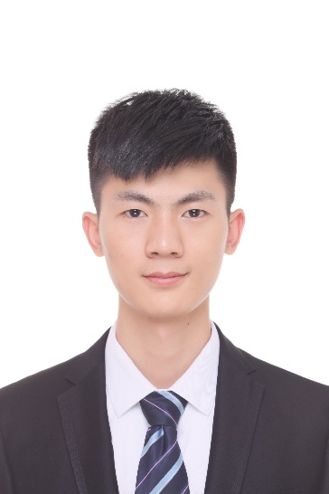

**Short Professioal details and affiliation:**

**Dr. Xingcheng Gan is a Lecturer at National Research Center of Pumps, Jiangsu University, China. His research encompasses hydraulic optimization of pumps, energy-efficient pump systems, computational-intelligence algorithms, and AI-driven design for fluid machinery. He earned his Ph.D. in Fluid Machinery from Jiangsu University and has authored more than 30 peer-reviewed publications.**

**Invited lecture  
*Enhanced Intelligent Strategies for Energy-Efficiency Improvement in Centrifugal Pump Systems***

**Abstract:** Rapid population growth and accelerating economic activity are intensifying pressure on energy supplies and the environment. Because centrifugal pumps alone consume roughly 17 % of global electricity, improving their efficiency is pivotal. Current approaches focus either on enhancing pump hydraulics to widen the high-efficiency operating region or on deploying intelligent system control to keep pumps within that region; however, rising expectations for energy performance and reliability have transformed these tasks into multi-objective, multi-parameter global optimization problems demanding superior modeling fidelity and algorithmic power. This study meets those demands by integrating AI-augmented numerical modeling—bolstering predictive accuracy, particularly under off-design conditions—with a deeply refined swarm-intelligence algorithm that accelerates convergence while maintaining robustness and effectiveness. Case studies demonstrate that the proposed framework can cut energy consumption by up to 70 %, preserve system stability, and outperform conventional single-variable control schemes, confirming its broad applicability and advantage for large-scale pump-system optimization.